**Additions and subtractions**

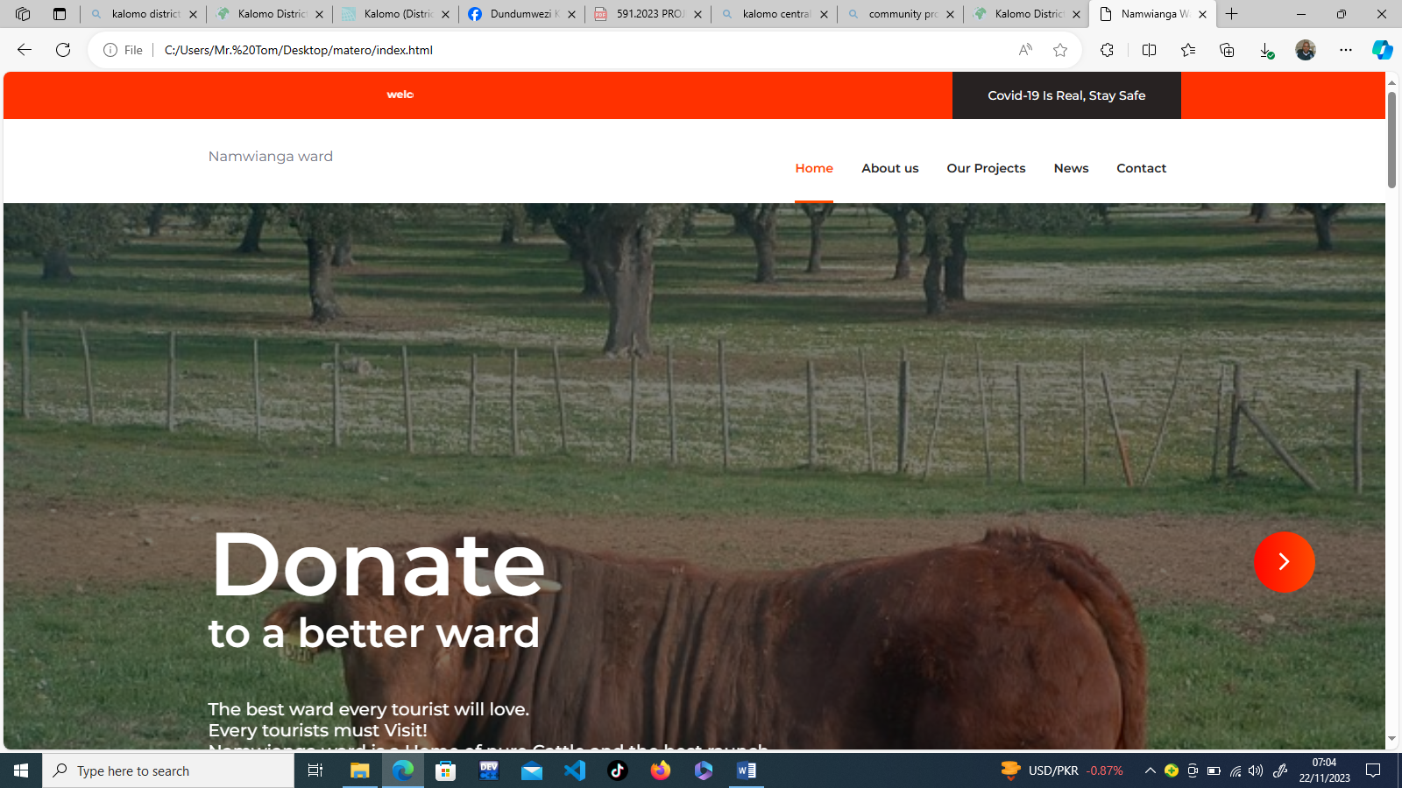

Should be bold and visible

Make then big and visible

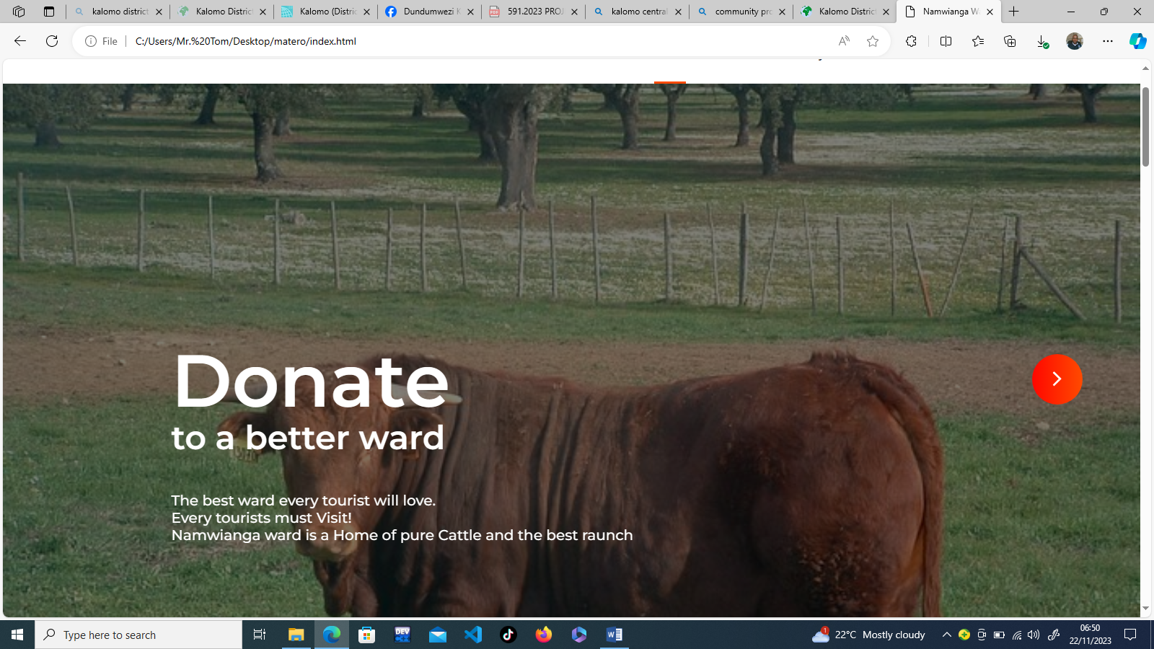

These pics should be rolling automatically [center them nicely]

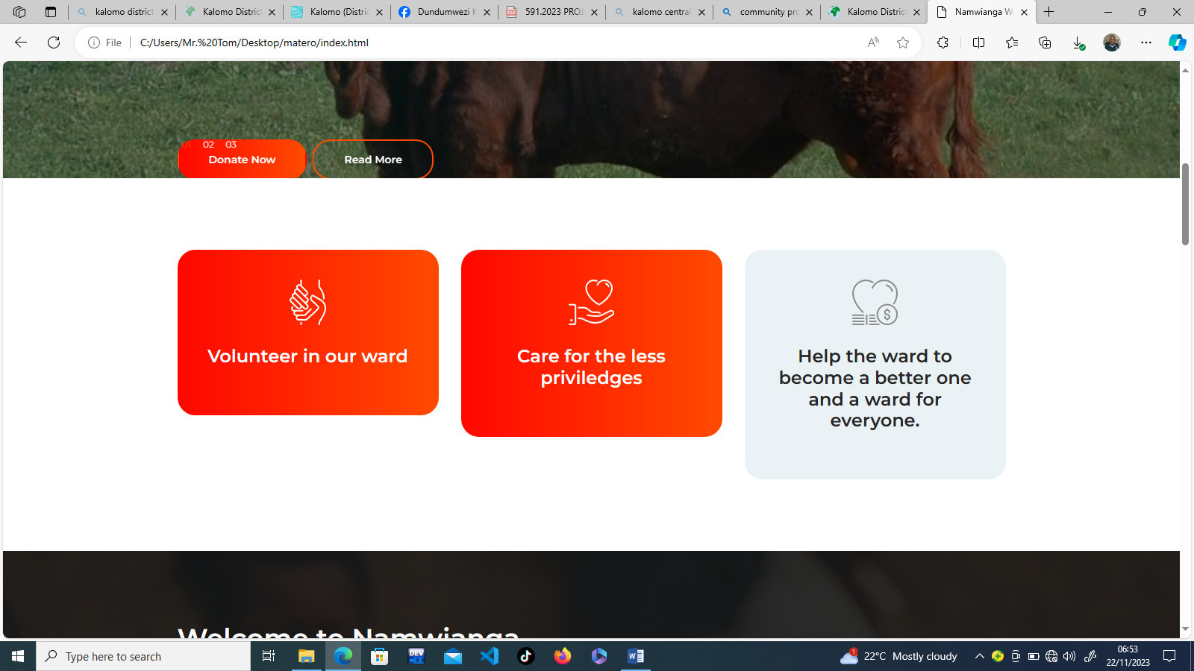

**Southern Province**

Remove all these and put “**Southern Province** is one of [Zambia](https://en.wikipedia.org/wiki/Zambia)'s ten [provinces](https://en.wikipedia.org/wiki/Provinces_of_Zambia), and home to Zambia's premier tourist attraction, Mosi-oa-Tunya ([Victoria Falls](https://en.wikipedia.org/wiki/Victoria_Falls,_Zambia)), shared with [Zimbabwe](https://en.wikipedia.org/wiki/Zimbabwe). The centre of the province, the Southern Plateau, has the largest area of commercial farmland of any Zambian province, and produces most of the maize crop.

**Kalomo District** is a [district](https://en.wikipedia.org/wiki/Districts_of_Zambia) of [Zambia](https://en.wikipedia.org/wiki/Zambia), located in [Southern Province](https://en.wikipedia.org/wiki/Southern_Province,_Zambia). The capital lies at [Kalomo](https://en.wikipedia.org/wiki/Kalomo). As of the 2000 Zambian census, the district had a population of 169,503 people

**Location**

We should have a map of the Kalomo district showing the location of Namwianga ward the particular ward. [Kalomo (District, Zambia) - Population Statistics, Charts, Map and Location (citypopulation.de)](https://www.citypopulation.de/en/zambia/wards/admin/0904__kalomo/)

**Statics**

Namwianga

9,785 Population [2010] *– Census*

521.7 km² Area

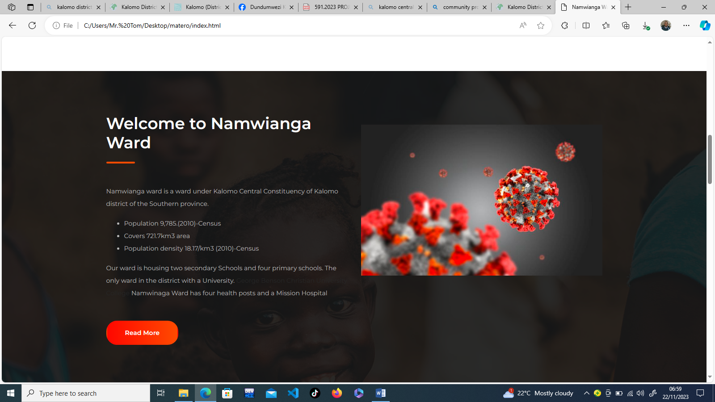

Interaction form here, where the public can chart or raise concerns about any ideas and plan etc.

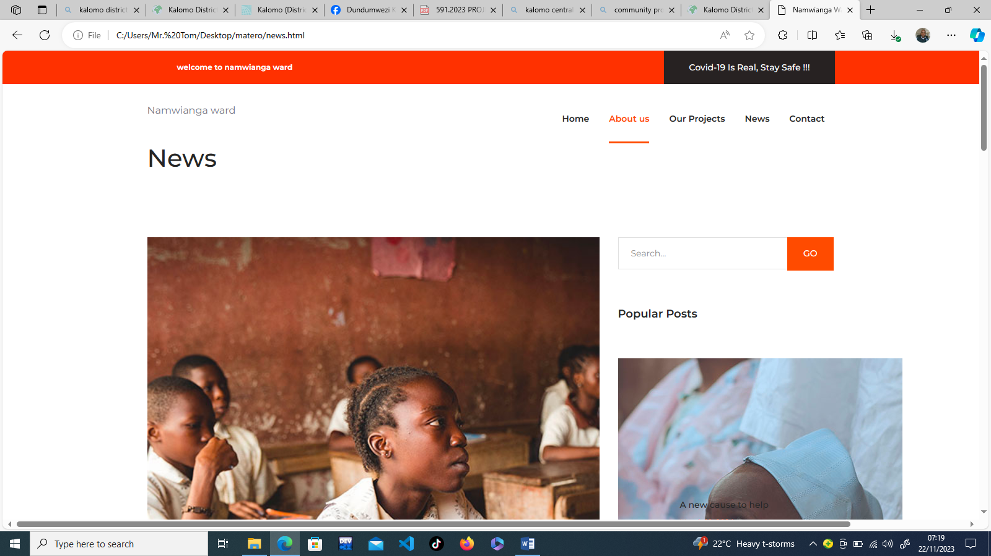

Some comments from the community

News feed

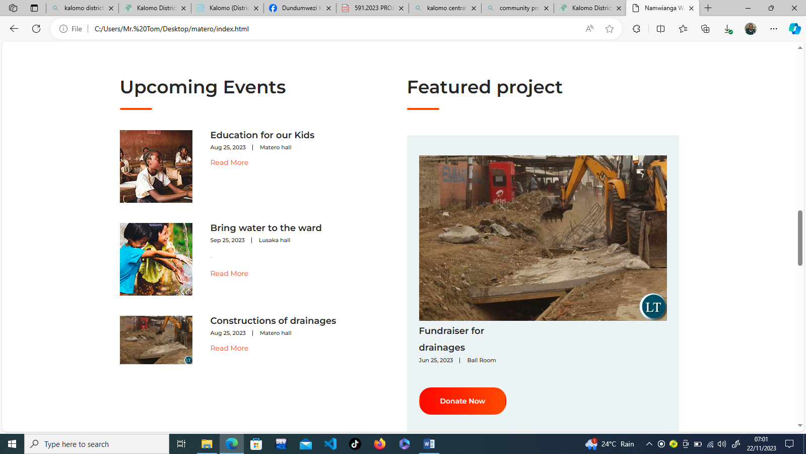

Leave it just the way it is